ADTA 4230 Final Project Report – An Analysis on Covid Testing
Matthew Flores, Benjamin Wilcox
University of North Texas

Table of Contents
ADTA 4230 Final Project Report – An Analysis on Covid Testing 3
Data understanding/EDA 4
Dataset Overview 4
Missing Data Analysis 4
Target Variable 5
Symptom Frequencies 6
Relationship Between Symptoms and Test Results 7
Contact vs. Test Result 7
Correlation Analysis 8
Age (60+) vs. Test Result 9
Sex vs. Test Results 10
Data preparation 11
[Heading 3] 11
References 13
Footnotes 14
Tables 15
Figures 16

ADTA 4230 Final Project Report – An Analysis on Covid Testing
The COVID-19 outbreak of 2020 brought to light a need for the ability to quickly identify infected individuals within a pandemic plagued by an ever-evolving virus. Laboratory testing provided the most accurate method of diagnosing infected persons; however, laboratory testing proved to be too slow of a process with results sometimes taking upwards of a week. Predicting which individuals were likely high-risk based on patterns of symptoms served as a pivotal tool for healthcare workers. Machine learning can be strategically leveraged to optimize the screening process and determine where to best distribute limited resources.
This project uses COVID-19 symptom data. Columns within the dataset map to symptoms and binary values indicate the presence of said symptom where a value of 1 means the symptom is reported. Each tuple (row) is mapped to one patient. The result column is the target variable. The target variable indicates if the patient tested positive or negative for the COVID-19 virus. Since the target variable is binary, this analysis serves to answer a classification problem.
The goal of this analysis is to create models that can accurately classify whether an individual is likely to be diagnosed as positive for the presence of COVID-19 using only the individual’s reported symptoms. Two supervised machine learning models are created to reach this objective which include the following: K-Nearest Neighbors (KNN) and Logistic Regression. The models are compared to determine which of the two is the most reliable in predicting if a user will be found to have tested positive for COVID-19.
The models will be analyzed to extrapolate many important insights. The first question aimed to be answered is which symptom correlates the strongest with a positive COVID-19 result. Next, the information provided by the models will be used to determine if symptom data alone is sufficient in diagnosing an individual. Lastly, through comparison of the models, the last question aimed to be answered is which of the two algorithms provides the best performance when it comes to classification. The purpose of answering these questions is to give a supplemental tool to healthcare workings

Data understanding/EDA

Dataset Overview
There is a total of 1,030,724 patient records found within the COVID-19 dataset. The dataset contains nine variables. The target variable is the result variable which can either be a string represented as positive or negative. There are five symptoms variables which include cough, fever, sore throat, shortness of breath, and headache. Additionally, there are two demographic variables related to the patient. These include the patient’s gender and whether they are of sixty years of age or older. Lastly, there is an informational variable to indicate if the patient has had contact with a person known to have tested positive for COVID-19. These eight variables make up the predictor variables.
The dataset is constructed entirely of binary variables. For values that are nonnumeric, values are still set to only one of two options. For example, values in the sex column can either be male or female. Because the dataset consists entirely of binary variables, it is well suited for a classification model. An exploratory data analysis was performed to gain insight into the structure of the data as well as identify any missing values before building the models. The exploratory data analysis also served to examine the balance between variables along with how relationships between predictors may influence the target variable.

Missing Data Analysis
Figure 1
Missing Values by Variable
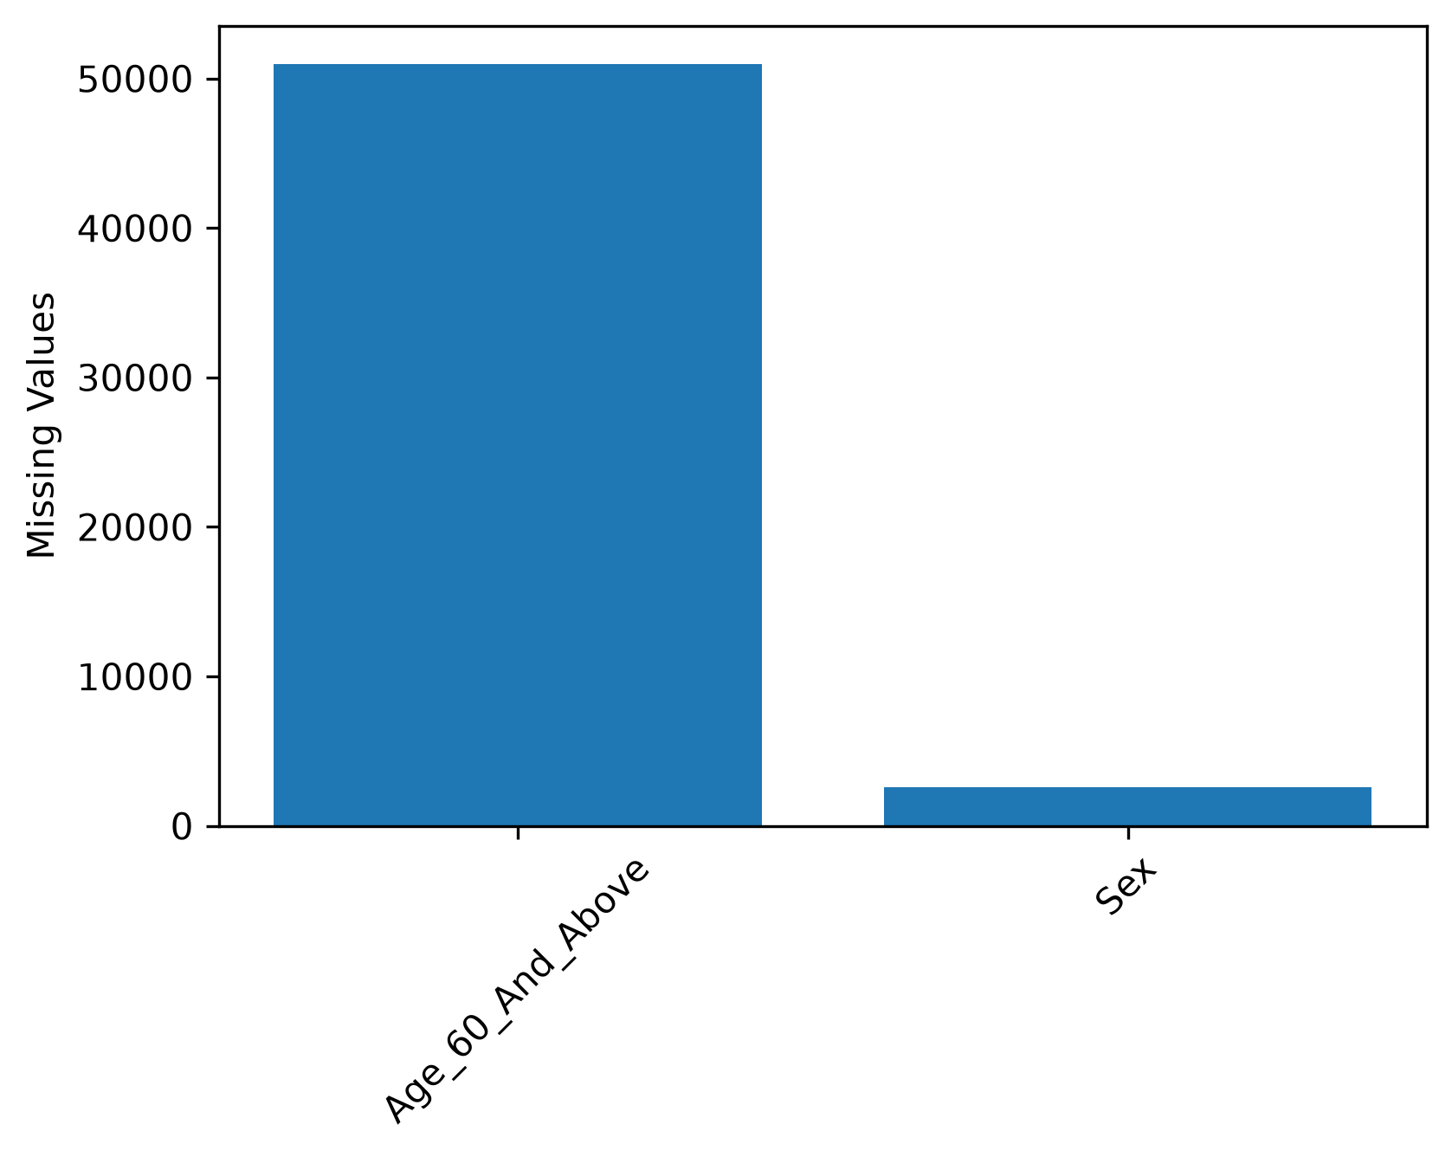
From the nine variables, only two columns contained missing data. Missing data was linked to Age_60_And_Above and Sex. The age variable was missing approximately fifty thousand values. Missing age values affected slightly under 5% of all patients. The sex variable was missing under three thousand values. Missing sex values affected approximately 0.25% of all patients.
Combined, the number of patients with missing data made up a relatively small proportion of the total dataset. During cleaning, these values were removed since affected patients fell slightly below the observed minimum threshold of 5%. All remaining variables contained complete information.

Target Variable
Figure 2
Distribution of COVID-19 Test Results
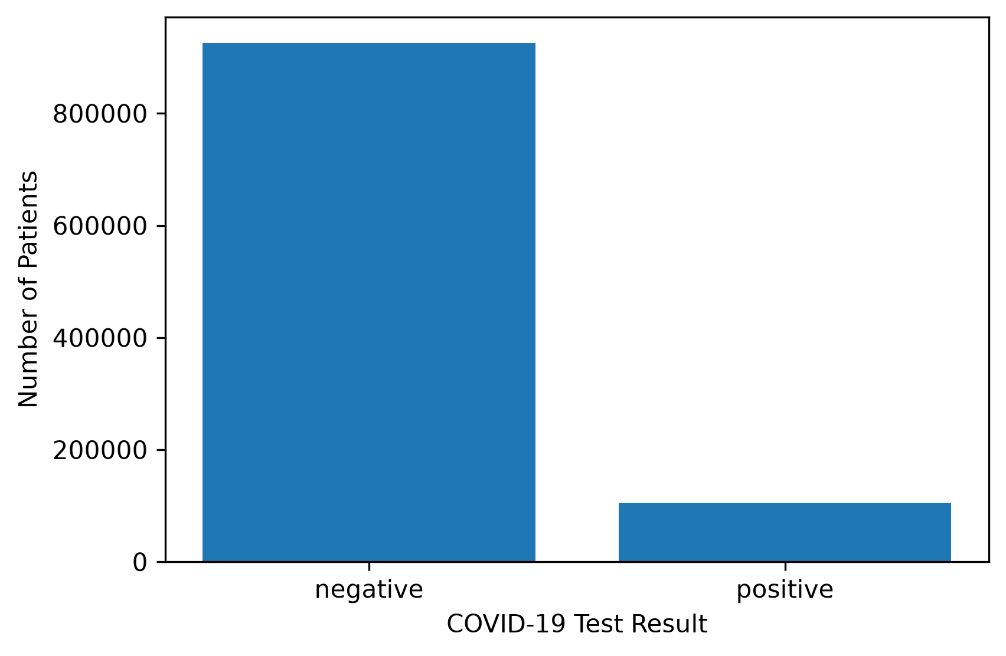
The distribution of the test results is imbalanced and favoring most patients as testing negative. It’s important to note the imbalance in classes because the models developed may favor the majority class which in this case is the group of patients diagnosed as negative for COVID-19.

Symptom Frequencies
Figure 3
Frequency of Reported COVID-19 Symptoms
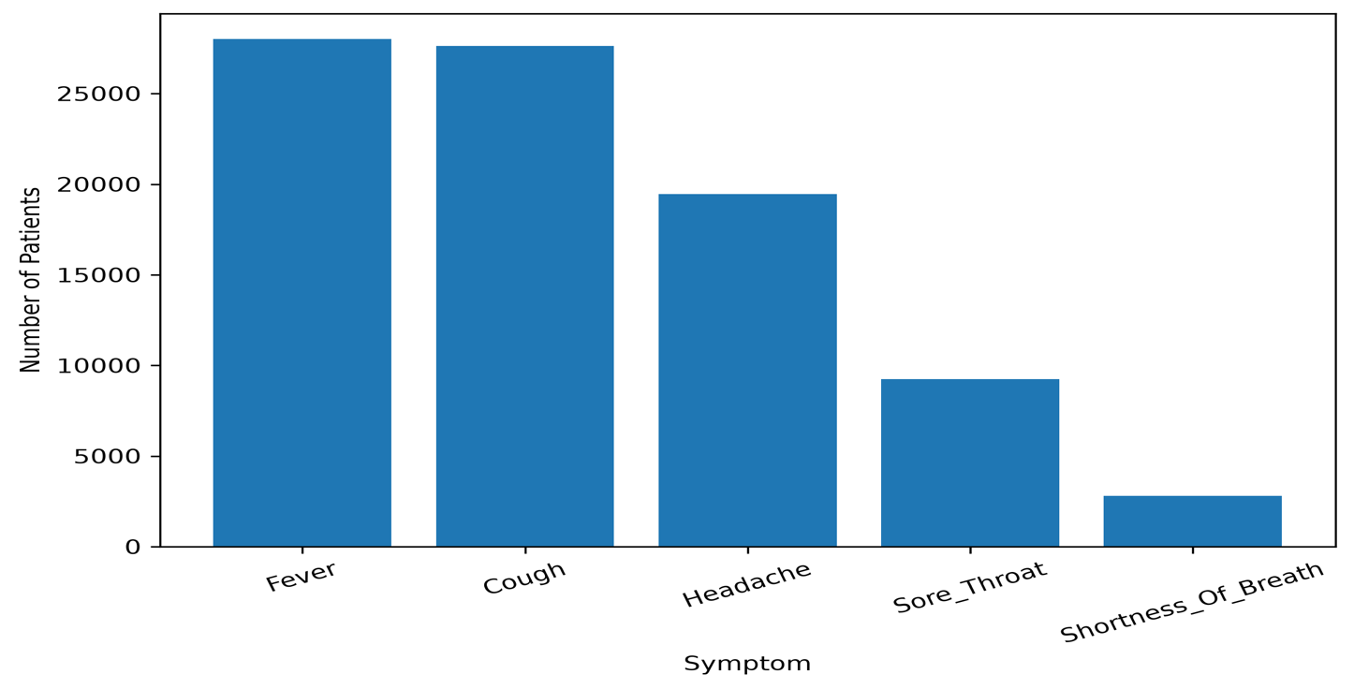
From the five symptom predictor variables, cough and fever appeared to be most frequently reported. Following cough and in respective order of frequency, the next reported symptoms include headache, sore throat, and shortness of breath. More frequently reported symptoms do not necessarily imply the presence of COVID-19; therefore, the connection between symptoms and the target variable are examined individually.

Relationship Between Symptoms and Test Results
Figure 4
Positive COVID-19 Rate by Reported Symptom
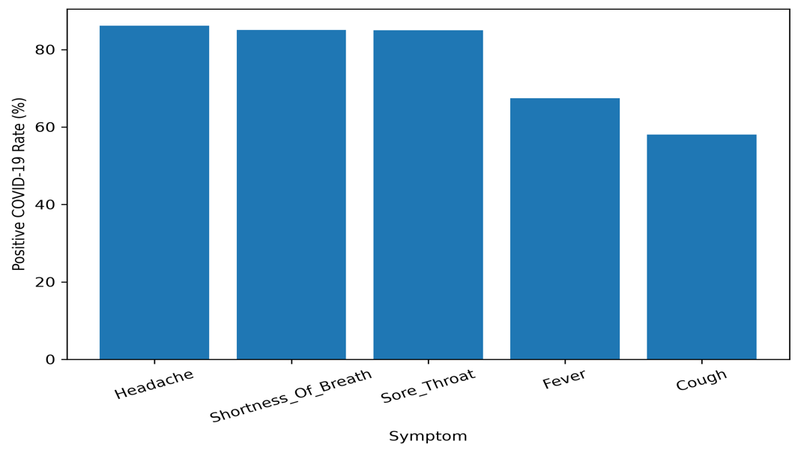
Sore throat, shortness of breath, and headache were the highest reported symptoms for patients who tested positive. Each symptom was present in approximately 84% of positive patients. Cough had the lowest connection with positive tests among all the reported symptoms. This suggests that some symptoms may be stronger predictors for the test variable.

Contact vs. Test Result
Figure 5
COVID-19 Test Result by Contact History
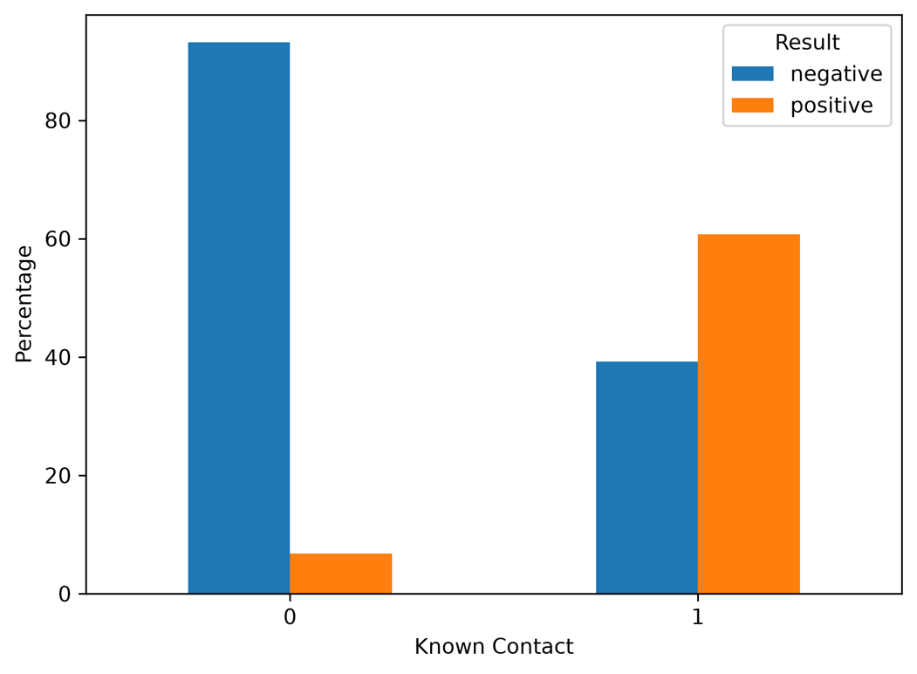
There is a strong association between exposure and infection. Among individuals with no contact, 93% tested negative, while 7% tested positive. Individuals with known contact, 61% tested positive and 39% tested negative. This suggests that contact with a person confirmed to have COVID-19 is a strong predictor of a positive test result.

Correlation Analysis
Figure 6
Correlation Matrix of Predictor Variables and COVID-19 Test Result
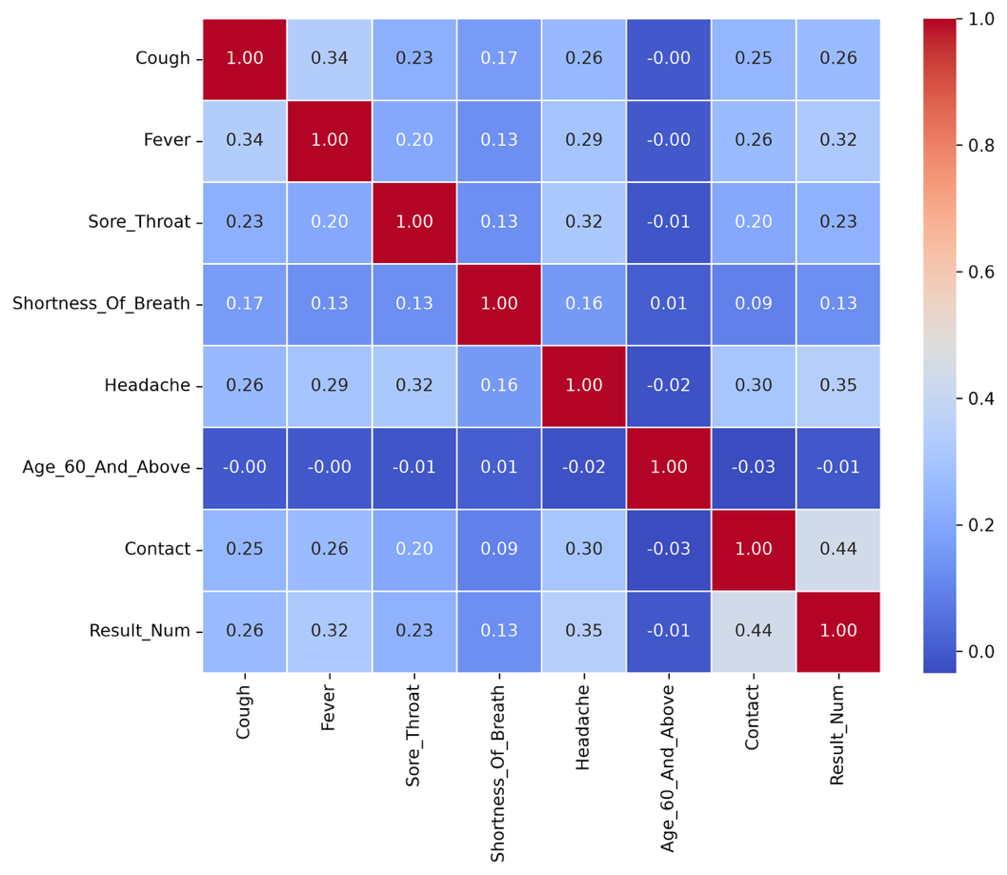
The correlation matrix shows that most predictor variables have weak positive correlations with one another, suggesting that each variable uniquely correlates to a positive test result. The strongest relationship with the target variable is Contact (r = 0.44). This indicates that contact with an infected individual is the strongest predictor of a positive COVID-19 test result. From the symptoms, Headache (r = 0.35) and Fever (r = 0.32) have the strongest correlations with a positive test result. Since no pair has a strong correlation, multicollinearity is unlikely to be a factor for the models developed.

Age (60+) vs. Test Result
Figure 7
COVID-19 Test Result by Age Group
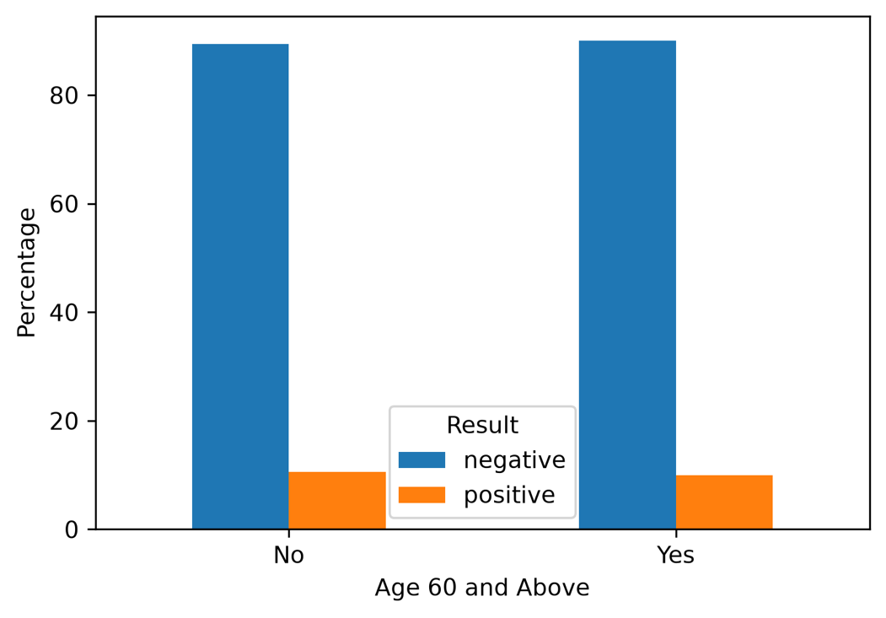
The relationship between age and test results shows no major difference between individuals over and under sixty. About 10.61% of individuals under sixty tested positive. About 10.01% of individuals sixty and above tested positive. This suggests that the Age_60_And_Above variable has little connection with positive test results.

Sex vs. Test Results
Figure 8
COVID-19 Test Result by Sex
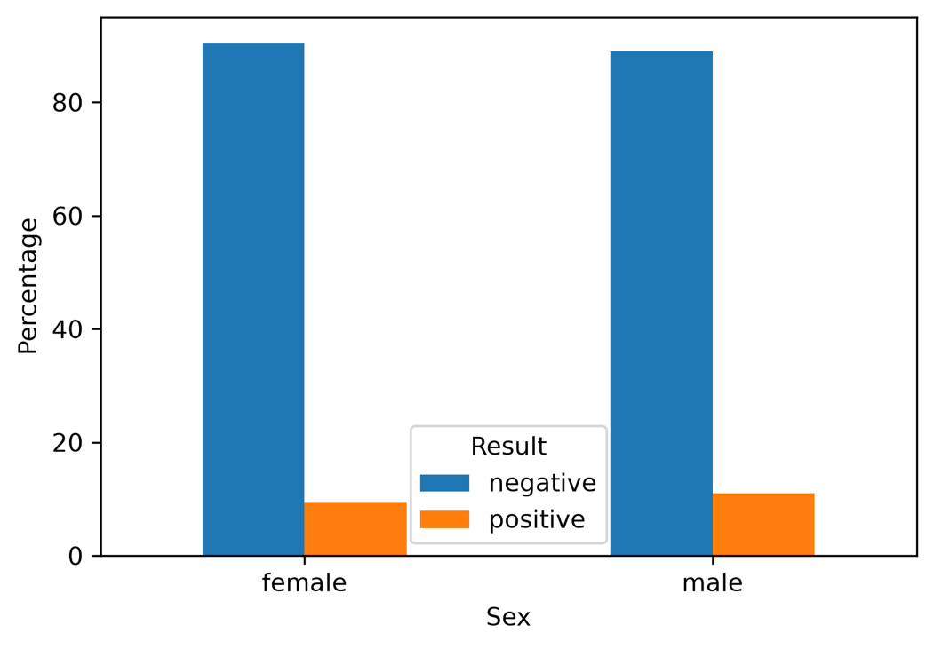
The relationship between sex and test results shows a small difference in positive test rates between male and female individuals. About 11.32% of males tested positive for COVID-19, while 9.78% of females tested positive for COVID-19. Although males were more likely to test positive compared to females, the difference between the two is small. This suggests that sex may only moderately influence the predictive models.

Data preparation

[Heading 3]. [Include a period at the end of a run-in heading. Note that you can include consecutive paragraphs with their own headings, where appropriate.]
[Heading 4]. [When using headings, don’t skip levels. If you need a heading 3, 4, or 5 with no text following it before the next heading, just add a period at the end of the heading and then start a new paragraph for the subheading and its text.] (Last Name, Year)
[Heading 5]. [Like all sections of your paper, references start on their own page, as shown on the page that follows. The body of the References section uses the Bibliography style. For more detailed information on formatting references, see the APA Style Manual, 6th Edition. (Last Name, Year)

References
Last Name, F. M. (Year). Article Title. Journal Title, Pages From - To.
Last Name, F. M. (Year). Book Title. City Name: Publisher Name.

Footnotes
1[Add footnotes, if any, on their own page following references. For APA formatting requirements, it’s easy to just type your own footnote references and notes. To format a footnote reference, select the number and then apply the Footnote Reference. The body of a footnote, such as this example, uses the Normal text style. (Note: If you delete this sample footnote, don’t forget to delete its in-text reference as well.)]

Tables
Table 1
[Table Title]
Column Head | Column Head | Column Head | Column Head | Column Head
Row Head | 123 | 123 | 123 | 123
Row Head | 456 | 456 | 456 | 456
Row Head | 789 | 789 | 789 | 789
Row Head | 123 | 123 | 123 | 123
Row Head | 456 | 456 | 456 | 456
Row Head | 789 | 789 | 789 | 789
Note: [Place all tables for your paper in a tables section, following references (and, if applicable, footnotes). Start a new page for each table, include a table number and table title for each, as shown on this page. All explanatory text appears in a table note that follows the table, such as this one. Use the Table/Figure style to get the spacing between table and note. Tables in APA format can use single or 1.5 line spacing. Include a heading for every row and column, even if the content seems obvious. To insert a table, on the Insert tab, tap Table. New tables that you create in this document use APA format by default.]

Figures

Figure 1. [Include all figures in their own section, following references (and footnotes and tables, if applicable). Include a numbered caption for each figure. Use the Table/Figure style for easy spacing between figure and caption.]
For more information about all elements of APA formatting, please consult the APA Style Manual, 6th Edition.

